CEE 3804: Computer Applications for CEE Spring 2012

Quiz 1
Date: February 23, 2007 Instructor: Trani

Honor Code Pledge

The information provided in this exam is my own work. I have not received information from another person while doing this exam.

Your Name ________________________________________________

Your Signature _____________________________________________

Write your solutions in a single MSWord file. Cut and Paste all your answers using screen captures. Show all your work. Label your file with your last name and CEE3804. Email your solutions to vuela@vt.edu and tao81@vt.edu. In the email header use the words CEE 3804 Quiz.

Problem 1 (40 Points)
An engineer formulates a linear programming problem as follows:

Maximize
Subject to:
and the non-negativity constraints and .
- Use Excel Solver to obtain the optimal solution. State the optimal value of Z.
- Write down the first table to solve the problem using the Simplex method.

Problem 2 (30 Points)
A formula to estimate the noise generated by rail vehicles is,
where:
= equivalent noise level (decibels in scale A - dBA)
= reference sound exposure level (decibels - dBA)
= number of cars in the train
= train speed (mph)
= hourly average train volume (trains per hour)
- Write a simple function in Visual Basic for Applications (VBA) to calculate the value of given values of v (speed), (sound exposure level), (train cars), and hourly train volume (q). The function created takes four input values for ,, and . The values of the four input variables are to be entered in the worksheet and should be read by your Visual basic code. Write back the result from the Visual Basic code calculation obtained for to the worksheet.
- Test your function using the following values: the train has 12 cars, the hourly train volume is 15 trains/hr and the train travels at 60 mph. The train studied is an electric locomotive with a reference sound exposure level value of 55 dBA.

Problem 3 (30 Points)
Short answers.
- An engineer has developed two long formulas to estimate construction cost ( ) and construction time ( ) for a new bridge. These formulas require eleven parameter values to do the calculations. Should the engineer use a function or a subroutine to these calculations. Explain why.

Examine the following VBA code.
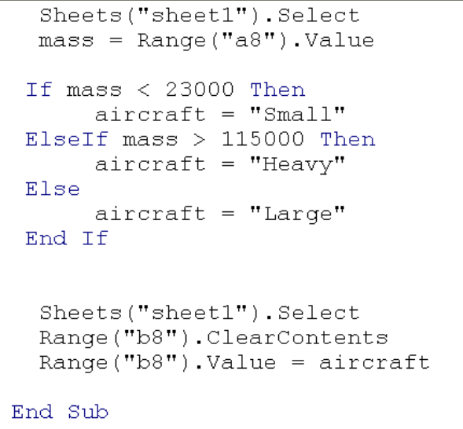
- In three lines explain the purpose of the code.

c) If the mass for an aircraft is 125000 kg what is the class assigned?

