CEE 3804: Computer Applications for CEE Fall 2013

Quiz 1 (50 minutes)
Date: September 30, 2013 Instructor: Trani

Open book and notes, use of computer is allowed

Honor Code Pledge

The information provided in this exam is my own work. I have not received information from another person while doing this exam.

Your Name ________________________________________________

Your Signature _____________________________________________

Write your solutions in a single Microsoft Word file. Cut and Paste all your answers using screen captures of your (in Windows you can use the Snipping Tool - under Programs/Accessories; on the Mac side use Grab - under Applications/Utilities). Show all your work including screen captures of Pivot tables, VBA code and Excel Solver. After you are done, save the single MS file as PDF to avoid artifacts with figures.

Label your file with your last name and CEE3804. For example, my exam file would be AntonioTraniCEE3804.pdf. Email your solutions to Ross Powers <rap2d@virginia.edu> and Yang Zhang <yang1990@vt.edu>. In the email header use the words CEE 3804 Quiz1.

Problem 1 (30 Points)
The data provided in the spreadsheet (see Table 1) contains construction equipment information for a medium size company located in Chantilly, Virginia.
a) Create a Pivot table that shows a summary of how many vehicles of each type the company owns at all locations and also the condition of the vehicles by vehicle type.
- Find the average age of the Komatsu PC78US-8 Excavators in “Good” condition at the Manassas construction site.

Table 1. Partial Table with Construction Company Equipment.
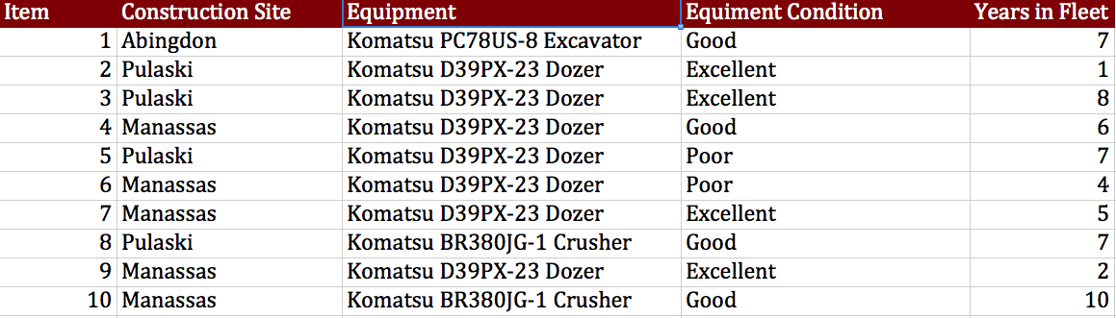

Make sure to make a screen capture of the Pivot Tables used to answer the questions (a) and (b) to get credit.

Problem 2 (40 Points)
A formula used in Geotechnical Engineering to estimate the void ratio - a measure of the compaction level of soil - is given in Equation (1),
(1)
- Write a function in Visual Basic for Applications (VBA) to calculate the value of given the values of all four variables in the right hand side of Equation (1). The VBA function should produce a single value ( ) as output. The values of the four input variables are to be entered in the worksheet and should be read by your Visual basic code. Write back the result for obtained in the Visual Basic code worksheet. Label all inputs and outputs appropriately. To check that the value of meets compaction standards, use a message box and write a message “Meets Compaction Standards” if the value of is less than 0.8. If not, write “Does Not Meet Compaction Standards”.
- Test your function using the following values: , , and .
Make sure to make a screen capture of the VBA function code to get credit.

Problem 3 (30 Points)
An engineer formulates a linear programming with two decision variables as follows:

Maximize
Subject to:
and the non-negativity constraints and .
- Use Excel Solver to obtain the optimal solution. State the optimal value of the objective function.
- Write down the first table to solve the problem using the Simplex method. In the table indicate what is the Initial Basic Feasible Solution (IBFS) including the values of all variables (both original and slacks, if any).

Make sure to include a screen capture of the Excel Solver panel showing the constraint equations to get credit.

