CEE 5614: Analysis of Air Transportation Systems Spring 2022

Assignment 1: Air Transportation Databases

Date Due: January 31, 2022 Instructor: Trani

Problem 1

Familiarize yourself with the Great Circle Mapper application (<http://www.gcmap.com//> ). Plan a trip from Newark International Airport (EWR) to Seattle-Tacoma International airport (SEA). repeat the process for a trip from EWR to Specifically, examine the distance traveled

a) Extract the great circle distance (shortest distance between two pints on the surface of the Earth) for these flights.

b) Now use the Flightaware web application (<http://flightaware.com> /) and examine flight information for Alaska Airlines Flight 8 (flight designation is ASA8 in the FAA Traffic Management Systems) between EWR and SEA by Alaska Airlines. Specifically, compare the ground track, cruise altitude and travel time for Alaska Airlines flight 8 on January 18, 21, and 22, 2022. Compare the actual distances “filed” in the pilot’s flight plan (these are typically stated as “Planned” distances in [flightaware.com](http://flightaware.com)) and compared against the great circle distances. Comment on the detour factor observed for each of the flights. The detour factor is the ratio of the distance flown and the great circle distance calculated in Part (a).

c) Extract the cruise altitudes (or sometimes called flight levels) for the flights selected in part(b) and comment on the altitudes flown.

d) Extract the travel times for all three flights and compare the average speeds flown by the aircraft (average speed here is the distance divided by travel time - this metric is called block speed). Draw some conclusions from the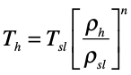 analysis. Specifically, comment on the cruise speeds and altitudes observed.

e) Use Flightaware to examine the travel times of the return flights for ASA8 from SEA to EWR on the same days as part (b). Based on the observed travel times, what conclusion can you make about Westbound versus Eastbound flights in the US

Problem 2

You are conducting a study of flight demand assessment for Charlotte International Airport (CLT).

a) Use the Transtats (or Bureau of Transportation Statistics) Aviation Database (see the Airport Snapshot link) to find the number of **flight departures scheduled and the number of departing passengers** at the airport in years 2018, 2019 and 2020. Make a plot (or a bar chart) and comment on the results observed. Comment on the effect of Covid-19 on the number of flight departures scheduled at the airport.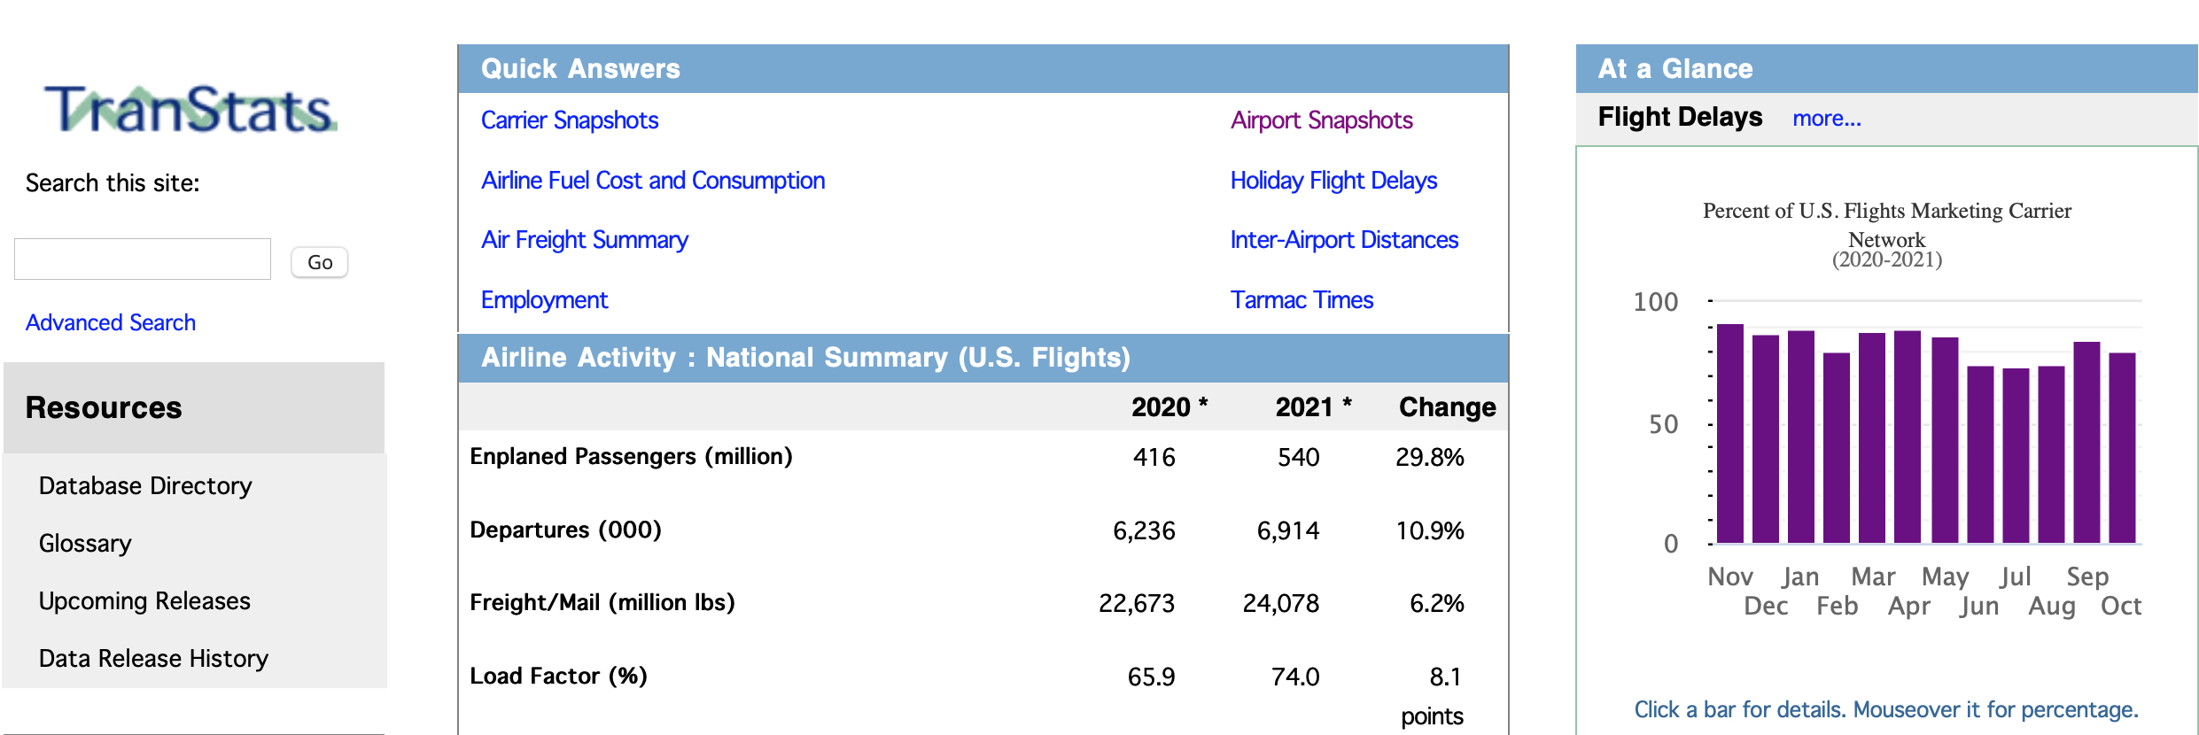

Figure 1. Front Page of Transportation Statistics Database (<https://www.transtats.bts.gov>).

b) Use the Transtats (or Bureau of Transportation Statistics) Aviation Database to find the top three airport destinations from CLT. Find the **number passengers between CLT and each of the top three destination airports in years 2018-2020.**  Comment on the effect of Covid-19 on the number of flight departures scheduled at the airport.

c) Use the Transtats Aviation Database to find the percent of flights that are on time (on-time performance) at CLT airport for years 2018-2020. Also find the average delay to flights that are delayed (average delay is only calculated for flights that are delayed). Comment on the effect of Covid-19 on the number of flight departures scheduled at the airport.

Problem 3

Download the average domestic airline US fares using the TranStats Aviation database for the **first quarter and years 2018-2020 (see Figure 2).**

1. Compare the average fares at CLT airport for years 2018-2020. Comment on any pattern observed and the effect of Covid-19 in airline fares at the airport
2. Compare the average fares at Roanoke-Blacksburg Regional Airport (ROA) for three years. Comment on any pattern observed.
3. In general, how do the average fares compared between CLT and ROA? State two possible reasons for the differences in fares.
4. Find the airport with the most expensive average fares in the US. Use Flightaware to find what kind of commercial flights are flown from that airport. Here we are looking if the flights are long and the aircraft equipment used.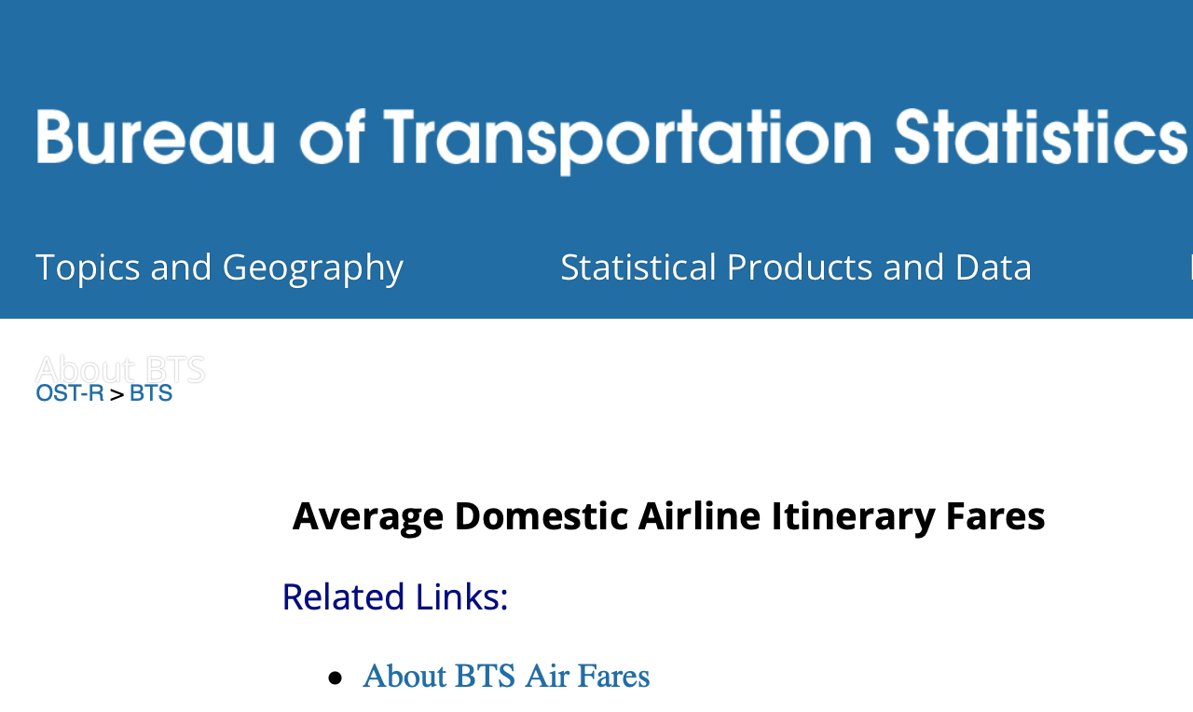

Figure 2. Average Domestic Airline Fares.

Problem 4

You are conducting a study of flight demand for the Los Angeles Airport (LAX).

a) Use the Aviation Database T-100 Domestic Segment (all carriers - see figure below) to download and study the number of domestic and international passengers at Los Angeles International Airport (LAX) by month for the period 2010-2020. Figure 3 shows an example panel for ATL airport.

b) Make a plot of domestic and international passengers at LAX in the period of analysis. Comment on the percent of international passengers at the airport over time.

c) Download the load factor data for the same period at LAX (2010-2020). Plot the data and comment on the trends observed. What is the effect of Covid-19 in load factor. Load factor is the percent of seats full at each flight.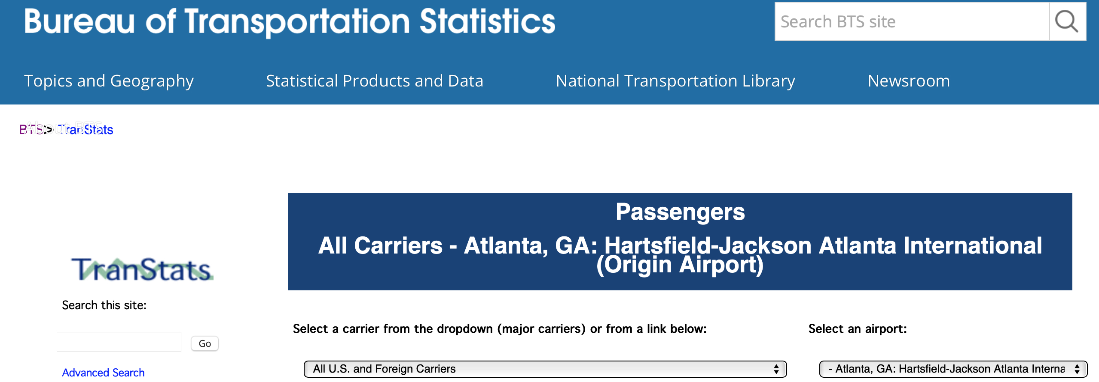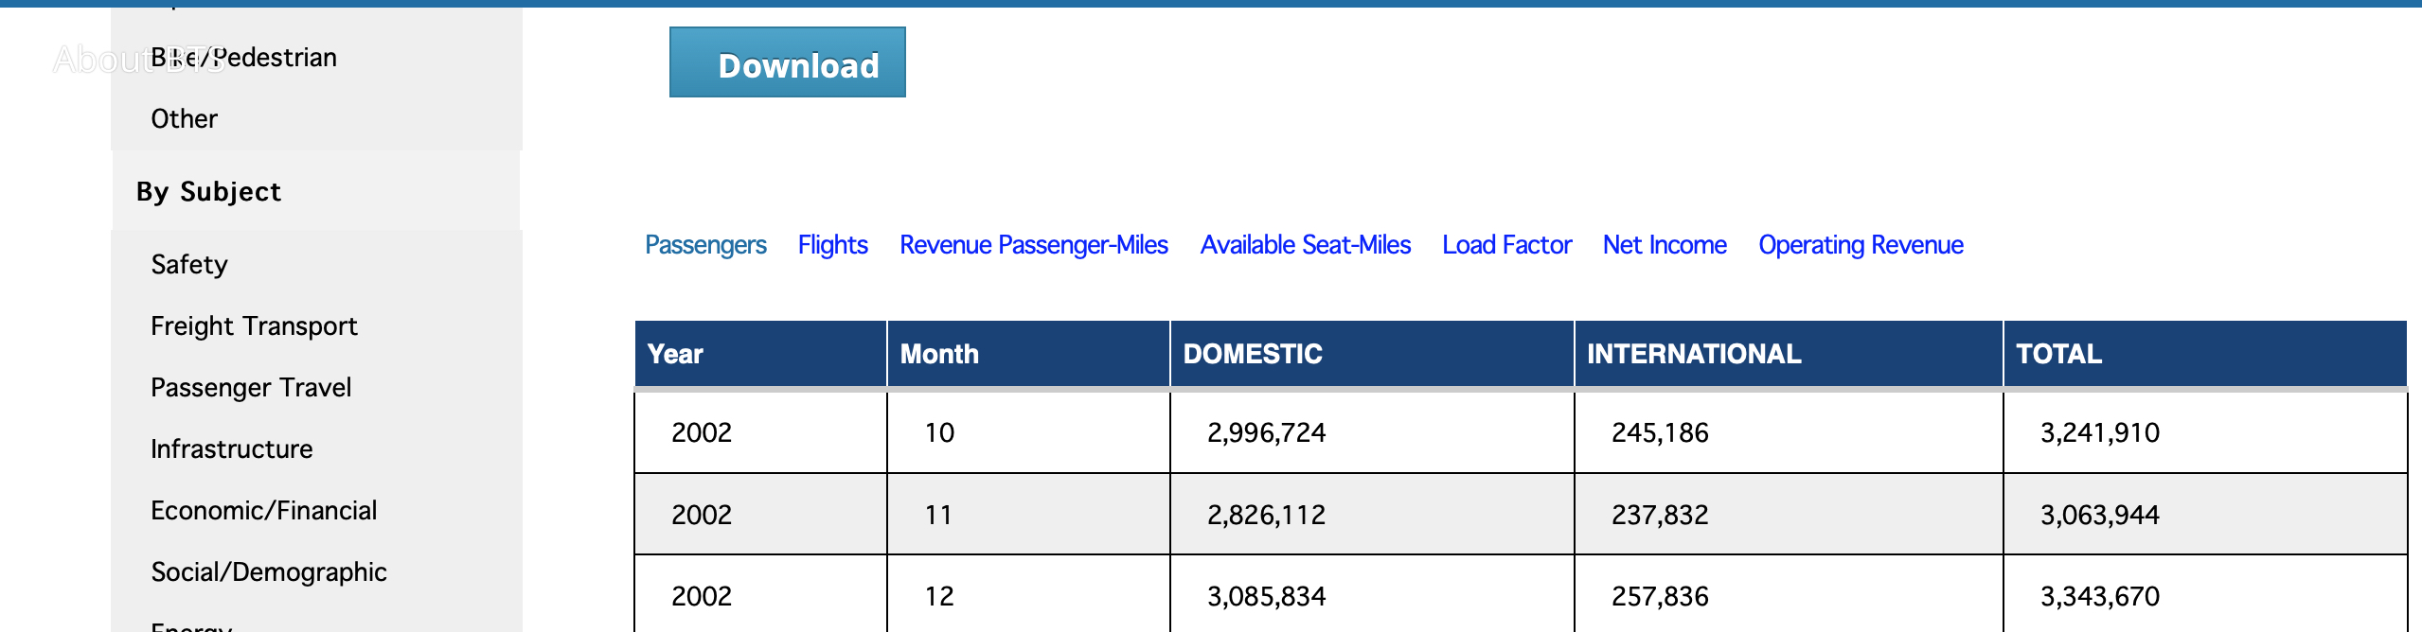

Figure 3. Air Carrier Statistics Panel for Atlanta Hartsfield-Jackson Airport.

Problem 5

1. Install the VT/FAA landing events database in your computer. The Landing Events Database can be found at: https://atsl.cee.vt.edu/products/runway-exit-design-interactive-model--redim-.html
2. Select CLT airport and extract the average landing speeds for Airbus A320 aircraft landing at runway 36L in the year 2019.
3. Find the average runway occupancy times at CLT runway 36L in year 2019.
4. Find the top ten aircraft landing on runway 36L at CLT in calendar year 2019. Calculate the percent of operations by each top ten aircraft.
5. Use the Airnav airport database and state the length of runway 36L at CLT.